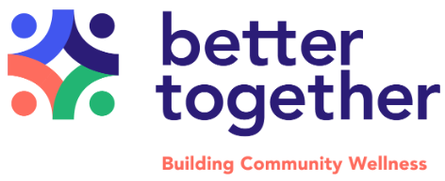
Request for Proposals
RFP: Better Together Collaborative Grants | Proposals Due By: October 20, 2025
Project Overview:
This request for proposals invites nonprofits, grassroots groups, student groups, businesses, places of worship, and even individuals to work together developing or enhancing an initiative that improves mental health and wellness for Nacogdoches County residents. The funding process is intentionally designed to be accessible in order to support community-designed solutions and distribute funds to those who might not normally have access to grants. Proposals must be collaborative in nature and address at least one of Better Together’s Common Agenda goals, listed below.
Common Agenda Goals:
- Affordable behavioral/mental health care services
- Youth social-emotional wellbeing
- Community supports for criminal justice-involved individuals with mental health challenges
- Affordable healthcare services
- Thriving economy for all
- Building awareness of wellness resources and community resources
- Basic needs (food, housing, childcare, poverty)
- Creating a physical environment that promotes healthy lifestyle
- Access to broadband internet for all
Strong proposals will demonstrate the following:
Collaboration: Two or more entities must partner on the project to address at least one of the Common Agenda Goals noted above. Each entity shall explain how the collaboration will help each other while meeting the needs of Nacogdoches County residents.

Addresses mental health and wellness: Initiatives should in some meaningful way improve mental health and wellness for Nacogdoches County residents by addressing at least one of the 9 Common Agenda Goals.

Target Population& Geographic area: Initiatives should benefit residents of Nacogdoches County, with special attention to historically excluded groups. Initiatives with potential to reach larger numbers of individuals will be given strong consideration.

Durability & Feasibility: Proposals should consider how the initiative will continue to operate or continue to benefit the community beyond the grant cycle. Proposals should also demonstrate that they are realistic within the proposed budget, timeframe, and organizational capacity.
How Grant Funds Can Be Used
Grants are intentionally flexible to align with community needs. Funding is unrestricted, meaning recipients have the flexibility to allocate funds where they are most needed to address mental health and wellness effectively and collaboratively. This approach ensures that resources can be directed toward urgent priorities, innovative solutions, and sustainable impact without unnecessary administrative restrictions. Grant funds may be used for a variety of expenses, including but not limited to:
- Personnel costs (salaries, stipends, and wages for staff, contractors, etc.)
- Program and project expenses (materials, supplies, and resources needed for implementation)
- Capacity building (professional development, leadership training, and technical assistance)
- Community engagement (stipends for community members, meeting facilitation, focus groups, community events)
- Technology and digital access (software, hardware, and other technology resources)
- Facilities and equipment (rental costs, utilities, office equipment that enhance program effectiveness)
- Transportation assistance (mileage reimbursement or other supports to ensure accessibility)

Grant funds may NOT be used for any partisan political activities, including lobbying, campaign contributions, or activities supporting any political party or representative. They also may not be used for debt repayment, endowments, or reserve funds.
Who is Eligibile?
- Non-profit organizations in good standing that have filed with the IRS
- Grassroots organizations, emerging organizations, and community-focused initiatives
- Places of worship / faith communities
- Businesses or individuals that can demonstrate the capacity to manage grant funds and to meaningfully address an urgent community need related to mental health and wellness
Potential recipients that are not 501(c)(3) non-profit organizations will be asked to provide additional documentation to demonstrate connection to the issue and fiscal responsibility.
Proposal Scoring Criteria
Proposals will be scored by a team of volunteers based on the following criteria:
Collaboration (25%)
- Does the proposal demonstrate a clear and meaningful collaboration between two or more entities?
- Does each entity explain how the collaboration benefits them/their mission?
- Does the proposal clearly state how this collaboration will improve mental health and wellness in a way that individual efforts would not?
Alignment with the Common Agenda (20%)
- Does the proposal clearly address at least one of the Better Together Common Agenda goals?
- Is the link between the project and the chosen goal(s) well-defined and compelling?
- Does the project comprehensively address the chosen goal(s)?
Project Scope and Feasibility (20%)
- Is the project well-defined and realistic within the given timeframe, budget, and capacity of both/all entities?
- Is there a detailed, well thought-out description of the project, including which entity is responsible for each activity?
- Is the proposed budget justified and reasonable?
Impact and Population (15%)
- Does the proposal outline how the project will impact a significant portion of the Nacogdoches County population?
- Does the proposed initiative benefit historically excluded groups? (This is broadly defined, proposals should clearly articulate why/if their target population is considered historically excluded)
- Are the expected outcomes clearly defined, and clearly beneficial to the target population?
Durability (10%)
- Does the proposal consider how the initiative might continue beyond the grant period? If funds will be used for any personnel expense, does the proposal explain how this will be addressed once the grant funds end?
- Will the impact of the project be lasting, regardless of the duration of the initiative?
Readiness to Implement (10%)
- Do the entities represented in the proposal demonstrate that they are the appropriate entity to address this need through this initiative?
- Do the entities demonstrate fiscal responsibility and the capacity to manage grant funds and implement the initiative as proposed?
- Does the proposal indicate a clear understanding of what success looks like for this initiative?
Measuring Completion & Success of the Initiative
Upon project completion, recipients will need to provide proof that funds were used in alignment with the proposal, as well as data supporting the impact of the initiative through objective and subjective measures. This may include attendance records, purchase receipts, photos, surveys, etc. Proposals should indicate what success would look like for this initiative, and how they plan to demonstrate or report on that success.
Recipients will be required to check in with Better Together staff on a monthly basis for updates.
Grant Funds
Proposals may be for funding amounts between $500 to $20,000 based on their project’s scope, capacity, and community impact.
Funds should be used within 6 months of issuance. If the initiative requires a longer timeline, proposals may justify this need and include plans to report to Better Together on progress.
Application Assistance
Better Together aims to ensure that the organizations and community members with innovative, impactful ideas are able to submit clear, strong proposals. Anyone interested in applying may reach out to Better Together staff via email to schedule in-person or virtual support with developing or completing a proposal. Contact Catie Munguia at catie@bettertogethernac.com
How to Submit a Proposal:
All proposals must be submitted using this ONLINE FORM. You will receive an email confirmation along with a copy of your responses upon submitting.

Below are the questions you will be asked to complete in the online form:
Basic Information
- Please provide a short title for your initiative (15 words or less)
- Please specify the total dollar amount you are requesting for this initiative.
Collaborators
- Provide the following information for the primary contact entity and all other collaborating entities:
  - Organization name (if applicable)
  - Individual contact person’s name
  - Type of entity (nonprofit, business, grassroots, religious organization, individual, etc.)
  - Phone number,
  - Email address,
  - Website (if applicable),
  - Mailing address,
  - EIN (for businesses and nonprofits)
- Which entity will be the fiscal agent for this initiative? (which organization / entity will receive and manage funds?)
Details
- Please provide an overview of your proposed initiative.
- Who in Nacogdoches County will benefit from this initiative? (This may include a geographic area, a specific population, people with a particular need, etc.) Specify if this initiative benefits any historically excluded groups.
- Which of the Common Agenda goals does this initiative address? (check boxes)
- What is the specific problem you seek to solve or need you seek to address through this initiative?
- Please describe in detail how this initiative will create a positive change related to the need or problem you identified. Make sure to connect this to the Common Agenda goal.
- How does this collaboration address this problem/need in a way that individual efforts could not? And why are you the ones to make this happen?
- Please provide a general budget for your initiative, listing the expense and amount, and a total project budget (ex: Food - $100, Stipends - $200, Equipment - $1000, TOTAL - $1,300). You may also attach a more detailed budget. Please describe if you will also use other sources of funding to support this initiative.
- Please provide a general timeline for this initiative, including at least a start date, end date, and major milestones.
Starting with the end in mind
- Describe how this initiative will continue to positively impact the community beyond the grant cycle.
- What would success for this impact look like? In other words, you would know this initiative had achieved what it sought to achieve if…
- How will you measure the impact of your project? Consider what data points you can collect, such as # of people served, feedback from beneficiaries, impact on the capacity of organization, etc.

Required Attachments and Submission Instructions
Required Attachments:
Attachments must be in PDF format and the title should clearly indicate the nature of the file and the initiative to which it applies. Attachments should be emailed to catie@bettertogethernac.com
- Nonprofit organizations
  - IRS Determination Letter
  - Most recent 990
- Businesses
  - EIN Verification Letter
  - A brief letter describing your business’s interest in and readiness to address this community need
- Grassroots Organization / other informal group
  - 2 letters of reference from community members with knowledge of the history and efforts of the group, particularly addressing the group’s fiscal responsibility and its connection to the particular issue/need it seeks to address
  - Brief letter describing the nature of the group
- Individuals
  - 2 letters of reference, particularly addressing your fiscal responsibility and your connection to the particular issue/need you seek to address.
  - Your most recent tax return (form 1040)
OPTIONAL Attachments
- More detailed budget
- Any other documentation that supports your proposal

Applications should be submitted electronically by 5pm on October 20, 2025.

For questions please contact: Catie Munguia, Better Together Associate Project Director
email: catie@bettertogethernac.com |  | Phone #: (936) 468-2228

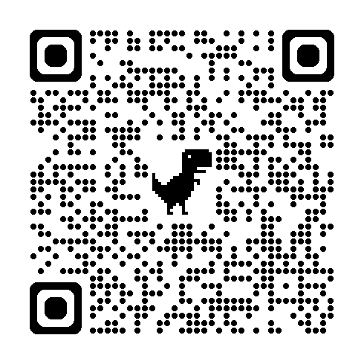
QR Code to the Online Form

